**Week 7 - Lab B**

**Problem: Number Processing**

Write a Python program that does the following:

1. Fill a list with the squares of numbers from 0 to 9.
2. Calculate the sum of all the elements in the list and print it.
3. Find and print the maximum value in the list.
4. Search for the first element in the list that is greater than 50 and print its index. If no element is found, display a message.
5. Count how many elements in the list are greater than 50 and store them in a new list. Print the new list and the count.

**Example:**

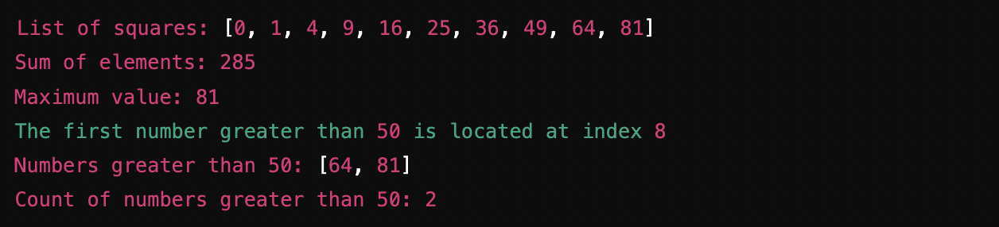

Paste the Screenshot of your source code below:

ls = [x ** 2 for x in range(10)]

print(f"List of squares: {ls}")

print(f"Sum of elements: {sum(ls)}")

print(f"Maximum value: {max(ls)}")

sls = [x for x in ls if x > 50]

if len(sls) > 0:

print(f"The first number greater than 50 is located at index {len(ls) - len(sls)}")

else:

print("No number is greater than 50 in the list")

print(f"Numbers greater than 50: {sls}")

print(f"Count of numbers greater than 50: {len(sls)}")

Paste the Screenshot of your output below:

List of squares: [0, 1, 4, 9, 16, 25, 36, 49, 64, 81]

Sum of elements: 285

Maximum value: 81

The first number greater than 50 is located at index 8

Numbers greater than 50: [64, 81]

Count of numbers greater than 50: 2

**Problem: List Manipulation**

Write a Python program that does the following:

1. Create a list of 5 integers.
2. Define a function calculate_sum() that takes a list as an argument and returns the sum of the elements in the list.
3. Define a function double_elements() that takes a list and a number (factor) as arguments and multiplies each element in the list by the given factor.
4. Define a function create_square_list() that takes a number as an argument and returns a list of square values from 0 up to that number (not inclusive).
5. Use the above functions to perform the following tasks:
   * Calculate and print the total of the integers in the list.
   * Double the elements of the list and print the modified list.
   * Generate and print a new list of squares for numbers from 0 to 5.

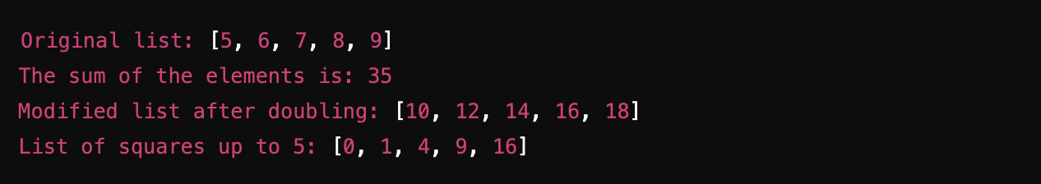

Paste the Screenshot of your source code below:

def calculate_sum(ls: list[int]) -> int:

sum = 0

for each in ls:

sum += each

return sum

def double_elements(ls: list[int], factor: int) -> None:

for i, v in enumerate(ls):

ls[i] = v * factor

def create_square_list(n: int) -> list[int]:

return [x ** 2 for x in range(n)]

ls = [5, 6, 7, 8, 9]

print(f"Original list: {ls}")

print(f"The sum of the elements is: {calculate_sum(ls)}")

double_elements(ls, 2)

print(f"Modified list after doubling: {ls}")

print(f"List of squares up to 5: {create_square_list(5)}")

Paste the Screenshot of your output below:

Original list: [5, 6, 7, 8, 9]

The sum of the elements is: 35

Modified list after doubling: [10, 12, 14, 16, 18]

List of squares up to 5: [0, 1, 4, 9, 16]